***Fee structure Proposal (****Principal)*

1. Click on the URL

URL: <http://10.30.30.29/sctsadmissions/index.php>

1. Login page

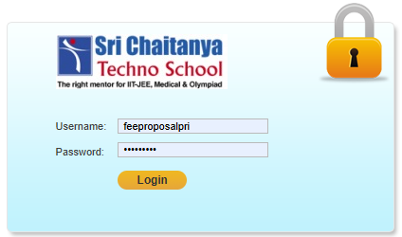

Enter your username and password.

1. Click on Feestructure Proposal

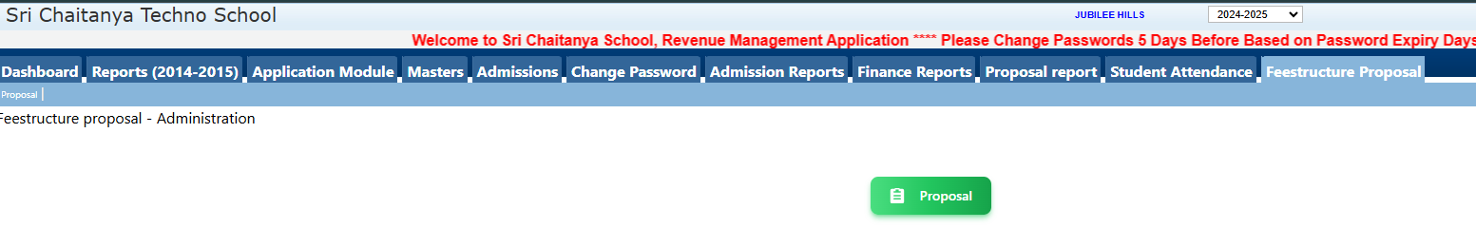

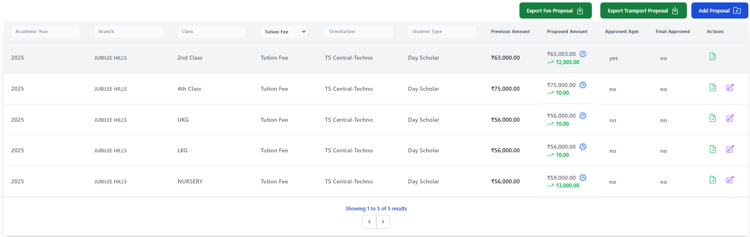

1. Click on Add Proposal to Add feestructure

Fill the required fields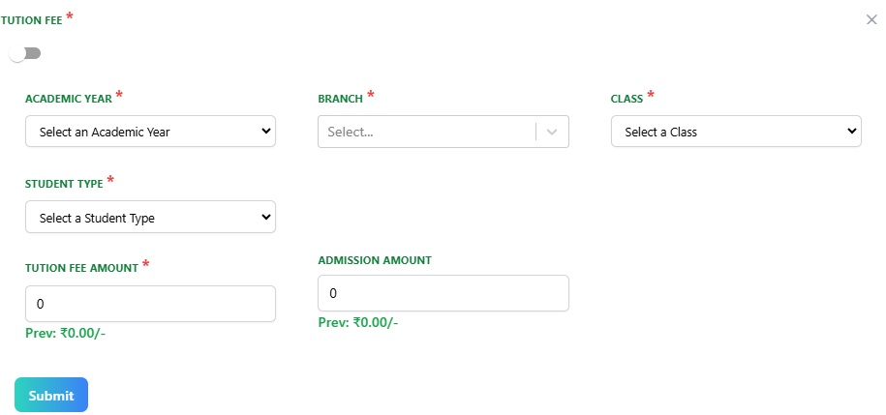

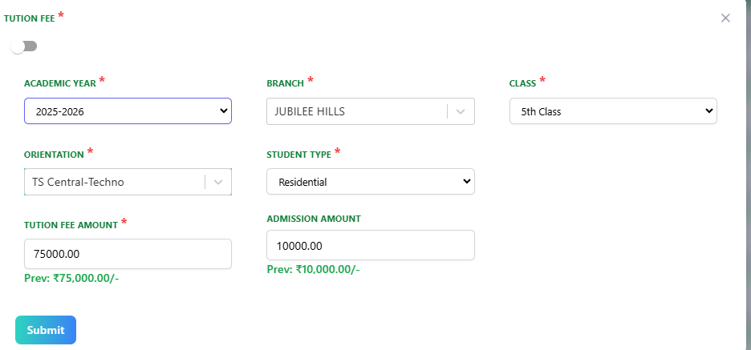

Note: The Amount should be equal or above the previous years amount, if entered less it shows pop up as shown

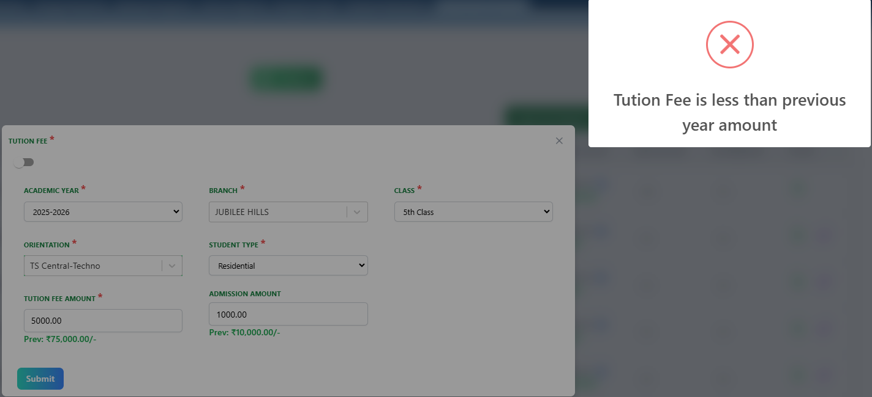

1. To Add Transport Fee switch to Transport fee as shown below

 

1. Fill the required fields

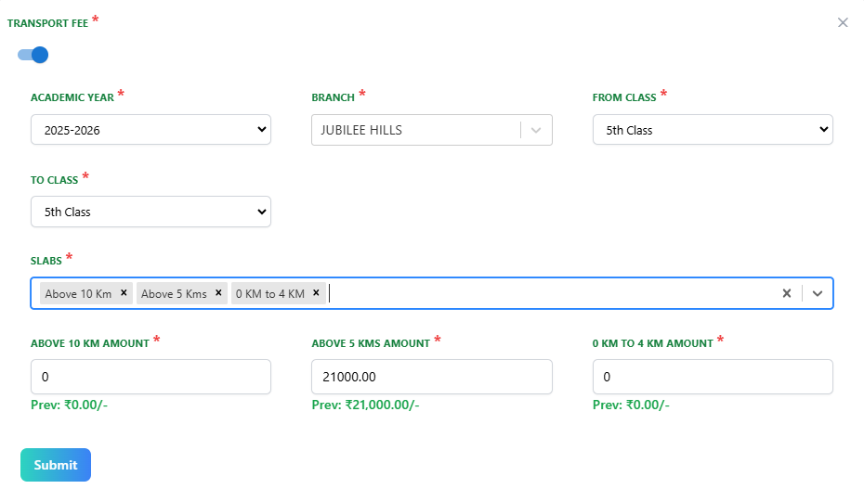

1. Add the amount correctly that should be above or equal to the previous year other wise error is shown in pop upA screenshot of a computer

   Description automatically generated
2. If added successfully shown in dashboard



1. Can sort through Fee Types also and can view details
2. If Approved by AGM can be seen as Yes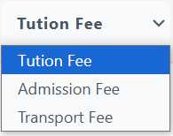

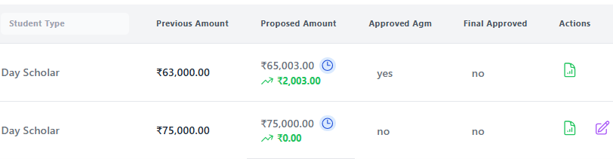

1. To view Click on view show in actions, check from the above image
2. Details are shown after clicking view as shown below

1. To Edit click on Edit symbol



1. Can edit as shown below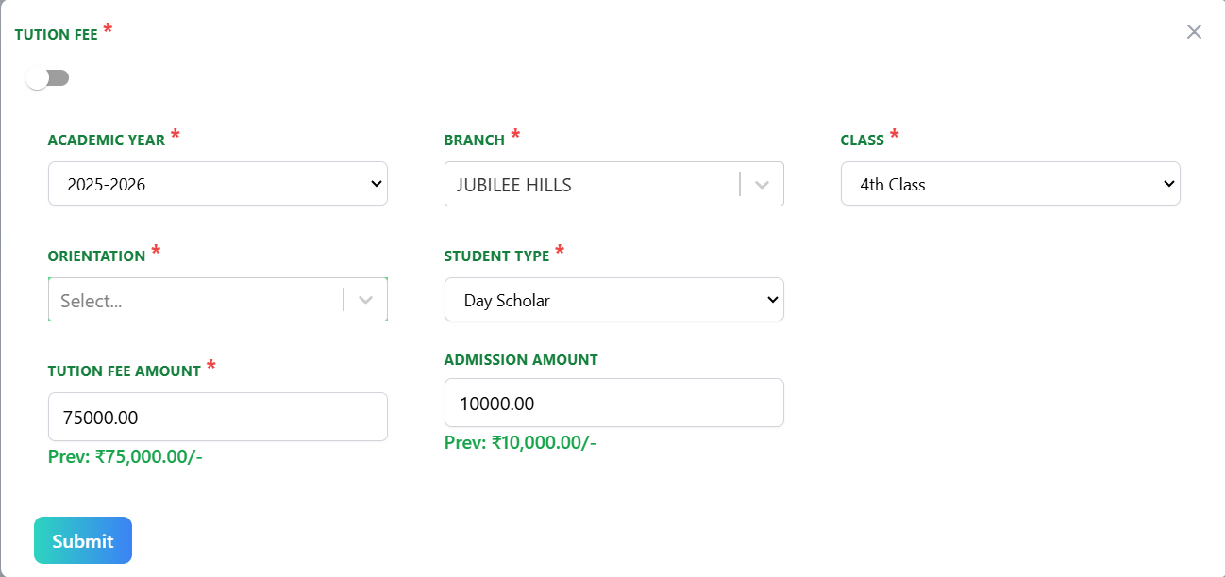
2. To select transport fee switch from Tuition fee to Transport Fee

 

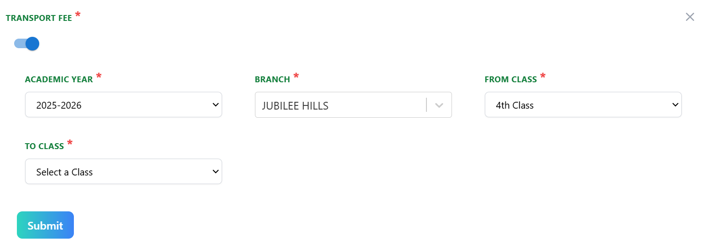

1. Fill the required fields



1. Add the amount correctly that should be above or equal to the previous year other wise error is shown in pop up

1. To Edit click on edit symbol as shown below



1. After Edit the fields are updated as shown in below

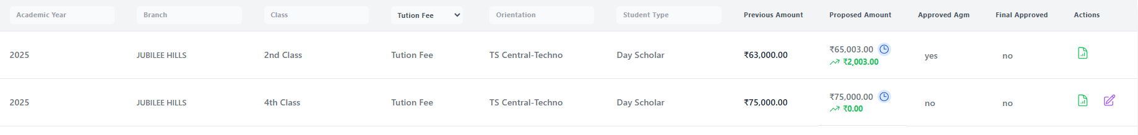

1. In view shown proposed amount and can also seen or compare previous amount with proposed amount.

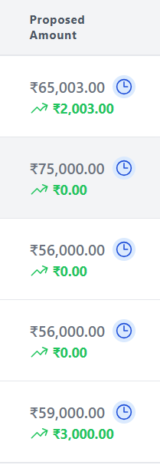 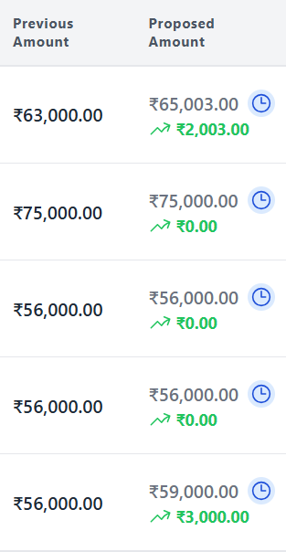

1. Click on the view symbol that shows the history of previous Entries amount and how many time it has been changed as seen in below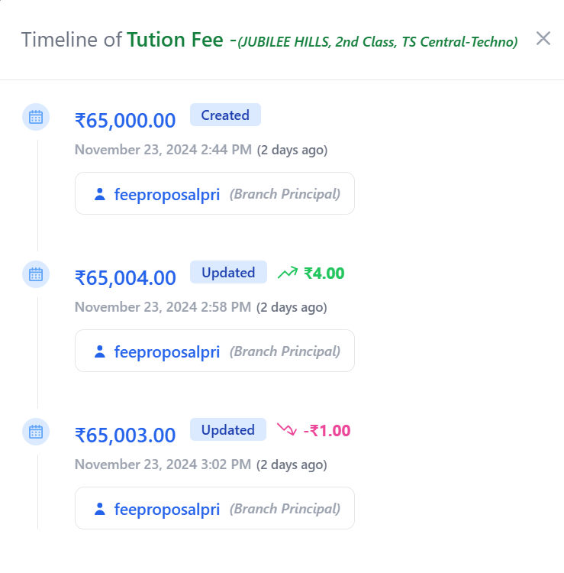
2. To get XL file for fee proposal and transport proposal respectively Click on export as shown below

**